The Encounter
The Encounter pioneers ground-breaking sound design that inspires the imagination. All patrons enjoy the show through individual headsets. Additionally, blind and low vision patrons can request written introductory notes prior to the show in accessible formats. Contact info@aaf.co.nz to receive the notes. Patrons can attend any performance, however a free touch tour will be held prior to the performance on Sunday 19 March. Patrons will be guided through the set, meet the performer and learn how the sound effects are created on stage. This international production has received five star reviews world wide and has been described as an experience not to be missed.
Wednesday 15 March - Sunday 19 March 2017
Venue: ASB Theatre, Aotea Centre, Auckland
Tickets: Adult A Res $82, Companion $41. Adult B Res $69, Companion $34.50 (booking fees apply)
Touch Tour: Sunday 19 March at 1pm
About The Encounter
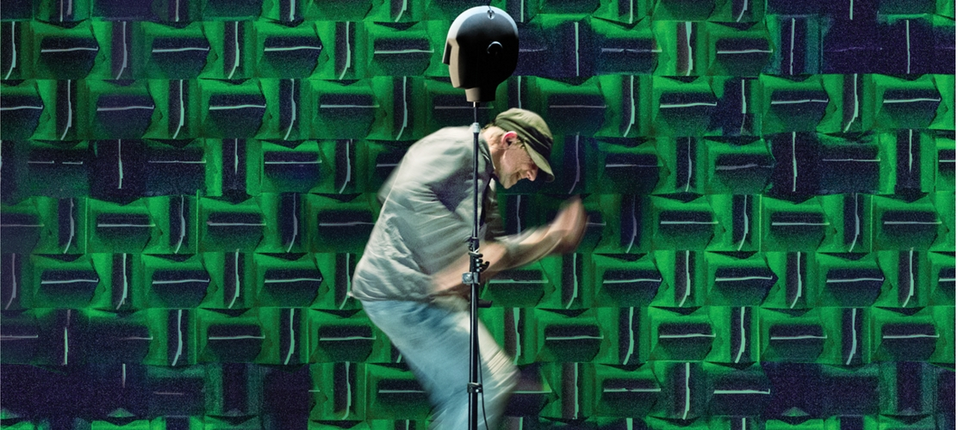
The Encounter tells the true story of National Geographic photographer Loren McIntyre who in 1969 becomes lost in a remote area of the Brazilian Amazon. This leads to a startling encounter that is to change his life.
Directed by Simon McBurney and hot from London, Edinburgh, Broadway and a sell-out season in Australia, this solo performance by Richard Katz traces McIntyre’s journey into the depths of the Amazon rainforest and uses binaural technology (3D audio) to build an intimate and shifting world of sound. As McIntyre’s mesmerising tale reaches its climax, this extraordinary performance asks some of the most urgent questions of today about how we live and what we believe to be true.
How to Book:
To book online click on the following link to access blind and low vision and companion tickets: Ticketmaster link for blind and low vision and companion tickets. To book over the phone call Ticketmaster 09 970 9705. Limited capacity so book early to avoid disappointment.
Duration: 1hr 50mins no interval

The Biggest
Audio Described Performance
Monday 13 March 2017, 7.30pm
Venue: Rangatira, Q Theatre, 305 Queen Street, Auckland
Audio Describer: Nicola Owen
Touch Tour: A free touch tour will take place at 5.30pm when patrons can be guided through the set, touch set pieces, feel costumes and meet a few of the performers.
Tickets: $39 plus $19.50 for a companion (booking fees apply)
How to Book
To book online visit Q Theatre website and select ticket type 'Accessibility' or 'Companion'. To book over the phone call Q Theatre on 09 309 9771
About The Biggest
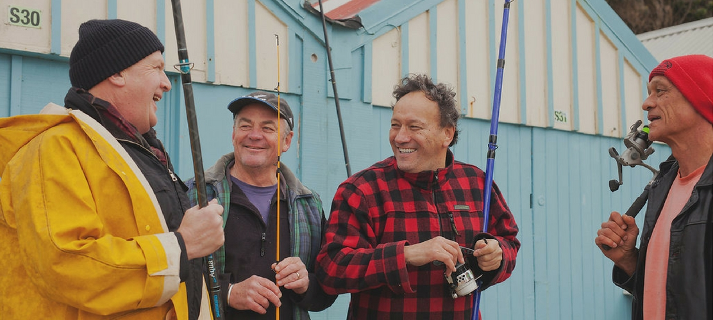
Written by award-winning New Zealand playwright Jamie McCaskill, The Biggest follows the adventures of a bunch of mates living some of the best years of their lives in small-town New Zealand.
The prestigious Hauraki fishing competition is coming up and Poppa, Pat and Mick meet at the local pub to welcome back wheelchair-bound Stu, who has been absent for months after writing off his new boat in a car accident. The men seize the opportunity to enter the fishing competition to try to win Stu a new boat. Standing in their way is the town's hottest fisherman, Jan Martin, who makes it his mission to get in the way of their prize.
Cast includes Peter Hambleton (The Hobbit), Tim Gordon (The Kick), Wesley Dowdell (Outrageous Fortune), Jim Moriarty and Apirana Taylor as the blokes and Kali Kopae as Cassie.
Contains strong language
Duration: 1 hour 30 minutes no interval
Lost At Sea
Children’s Theatre: 8 years plus
Audio Described Performance
Audio Describer: Kevin Keys
Friday 17 March 2017, 6.30pm
Venue: Loft, Q Theatre, 305 Queen Street, Auckland
Touch Tour: A free touch tour will take place at 5pm when patrons can be guided through the set, touch set pieces, feel costumes and meet the performers.
Tickets: Adults $22, Child $15, Companion $11 (booking fees apply)
How to Book
To book online visit Q Theatre website and select ticket type 'Accessibility' or 'Companion'. To book over the phone call Q Theatre on 09 309 9771
About Lost At Sea
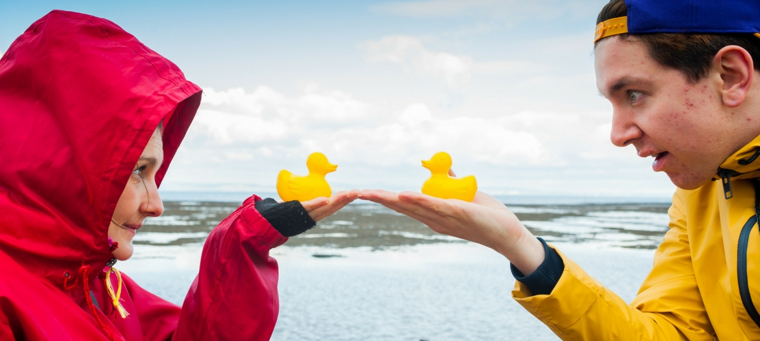
Award-winning theatre company Catherine Wheels find themselves Lost at Sea as they explore the biggest subject one can possibly try to tackle – the ocean.
The journey begins with a boy and a girl, fascinated by the true story of 28,800 yellow rubber ducks and other bath toys that were accidentally flung into the unrelenting currents of the Pacific Ocean. The children’s investigation sees them uncovering the mysteries of the sea and discovering its importance to every one of us on earth.
Inquisitive and immersive, Lost at Sea weaves together the wonder of theatre and the dynamic world of science.
Duration: 1 hour no interval

