SHOPPING CART INSTRUCTIONS

Want to book more than one Festival show?
Want to save on booking fees? Now you can!

- Once you’re at www.aaf.co.nz browse the shows and decide which ones you’d like to see. Click on the “add to cart” button. Next, select the performance date and click on “add”.

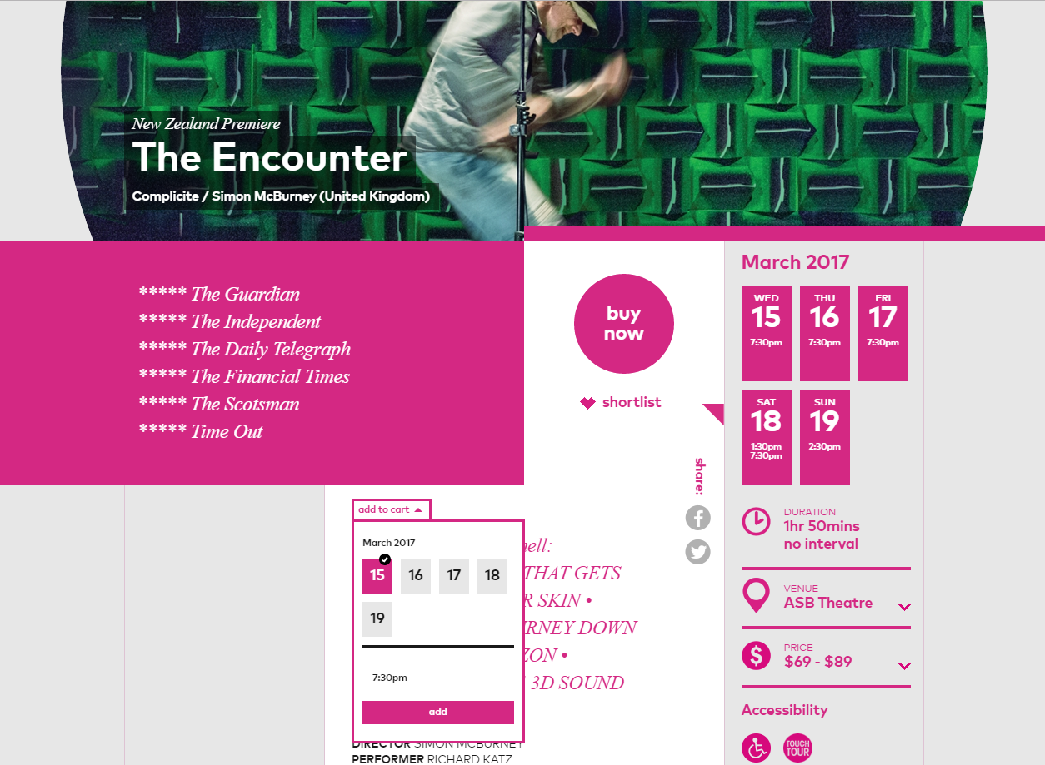
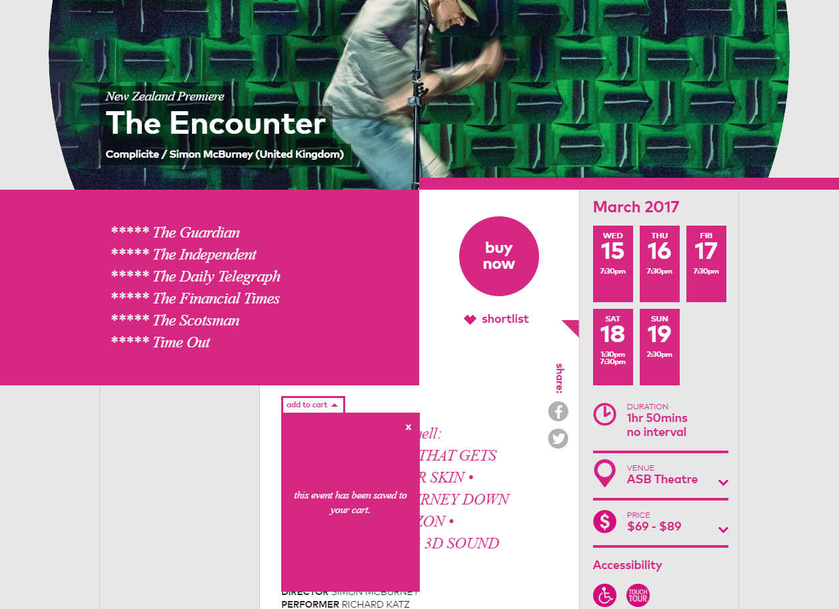

- Every event you select in this way will be saved to your Shopping Cart.

- Continue this process for all the shows that you wish to book.

- Once you have finished choosing your shows select “My Shopping Cart” from the menu at the top of the page
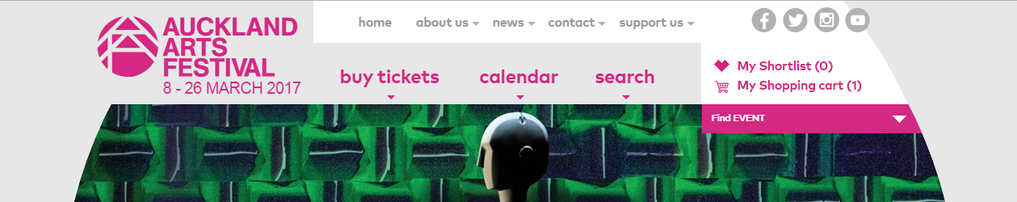

- Your shopping cart will display the performances that you have selected. Here you can also edit or remove items if you’ve changed your mind…

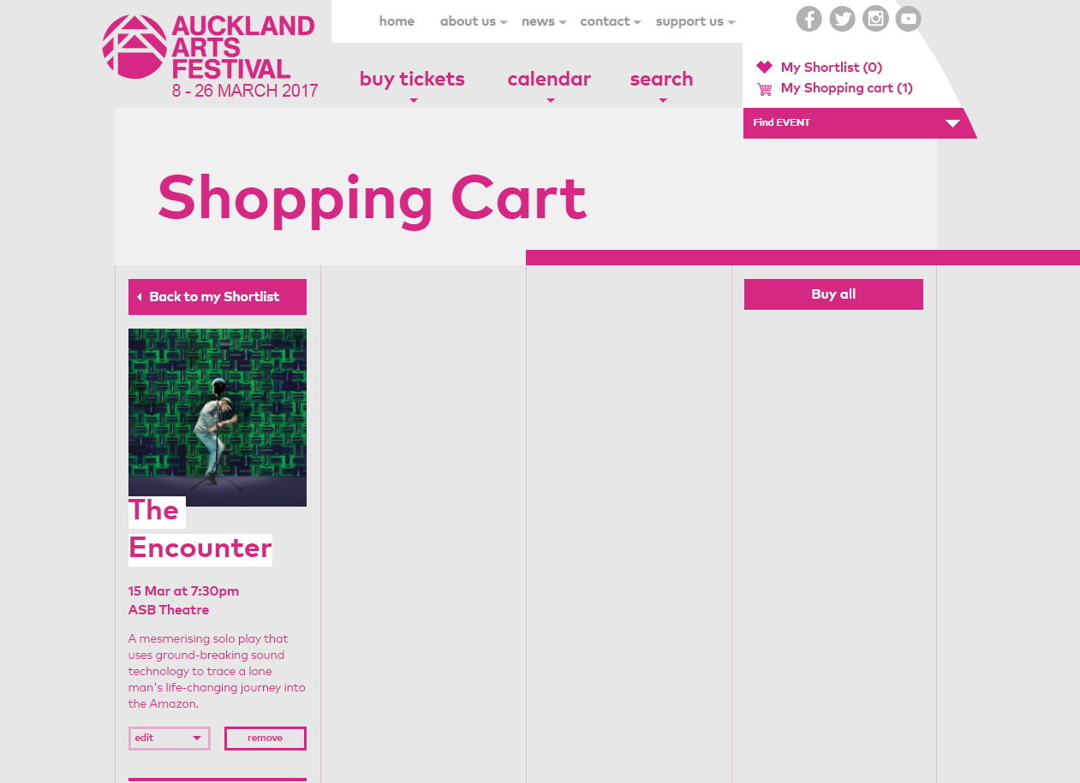

- To purchase your tickets select the “buy all” button. Clicking this button will redirect you to the Ticketmaster website where you can select your seats and price type and complete your purchase. You will be charged only one booking fee (plus any credit card charges).
