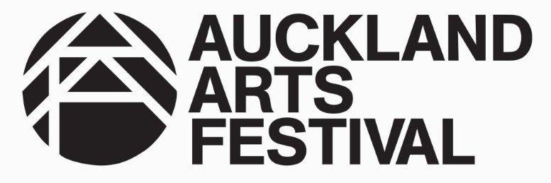

Auckland Arts Festival Artists Alliance Intern

The Artists Alliance Internship Programme 2017 is now calling for applications from recent graduates for a fixed term, paid internship with Auckland Arts Festival. The aim of the programme is to provide a valuable opportunity for graduates to obtain significant work experience in the arts industry. The programme has been made possible with generous funding from Foundation North.

The Auckland Arts Festival is Auckland's premier festival of New Zealand and international arts. The globally-recognised event celebrates people and culture, and showcases the cultural diversity and vibrant energy of New Zealand's largest city. More than 1.5m people have attended the event, which is now annual. The next Festival runs from March 8-26, 2017.

The Auckland Arts Festival Visual Arts Programme includes a major exhibition co-presented with Te Uru Waitakere Contemporary Gallery, an exhibition commissioned by Te Tuhi and presented in association with Auckland Arts Festival, and a free large-scale installation projected on the Auckland War Memorial Museum co-presented by Auckland Arts Festival and Auckland War Memorial Museum. The Festival also produces and co-ordinates the city-wide White Night and Whānui, an engagement project across the region that matches professional artists with community participants, and presents a number of other exhibitions with partner galleries across Auckland.

The intern will assist the Programming team in delivering a number of Festival events with visual arts components, including a large-scale, international, outdoor installation at the Domain titled Power Plant. This is a great opportunity to get to know Auckland Arts Festival and work as part of a professional arts events team. The intern will gain work experience and learn about the installation of international artworks. This role would suit a recent visual arts graduate.

Eligibility

For the purposes of this internship programme those eligible to apply will need to have graduated within the past five years (from 2012 onwards) with a New Zealand tertiary arts qualification. The applicant must be based in Auckland for duration of the internship.

Position Title

Visual Arts (Auckland Arts Festival) Intern
Reporting to: Head of Programming and other delegated Programme Managers as directed
Location: Level 5 Wellesley Centre, 44-52 Wellesley Street, Auckland Central

Tasks / Key Responsibilities

Tasks will include supporting the Head of Programming and Programme Managers to:
- Work with the international artists and the Festival event team on the logistics and delivery of Power Plant.
- Assist with other Visual Arts Programme activities where required including White Night events, or Whānui.

Essential skills
- A strong interest in the arts (visual arts and/or performing arts) and events
- Good Word, Outlook and Excel skills
- Excellent communication skills, both written and verbal
- A full, clean drivers licence (essential) and own car (desirable)
- Adaptability, especially in response to the needs of the artists or community groups
- Strong organisational skills
- Strong attention to detail
- Comfortable working outdoors and with your hands
- Ability to work under pressure and as part of a team.

Timeframe & Remuneration

The internship will consist of a fixed term contract for approximately 8 weeks beginning January 31, 2017.
The intern’s normal hours of work will be 20 hours a week for the first 3 weeks, then 40 hours a week from February 20 to March 26, to be worked between the hours of 8.00am and 6.00pm.
During Festival time, March 8-26, evening and weekend work is required, and flexibility is essential.
Remuneration will be $17 per hour.

How to Apply

Please email your CV including two referees and a covering letter explaining why you think you would be suitable for the above position to:
Maggie Gresson
Artists Alliance
Email: maggie@artistsalliance.org.nz

Deadline for Applications

Applications must be completed in full and emailed to Artists Alliance no later 5pm Monday November 28. Interviews will take place in the week beginning December 5. Applicants must be available for potential interviewing during this week, dates to be confirmed.
